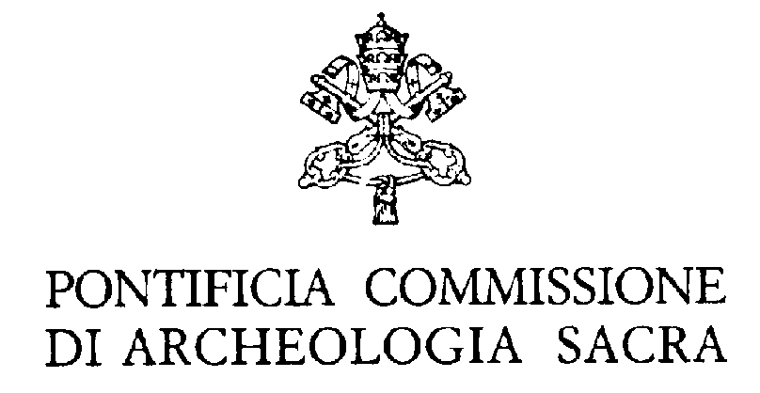 dal Vaticano, 13 maggio 2013

RULES REGARDING VISITS TO THE CATACOMBS CLOSED TO THE PUBLIC

The Pontifical Commission for Sacred Archaeology (when the conditions of the monument permit this) also offers the possibility to students, individual scholars and Cultural Associations to have access to the catacombs that are normally closed to the public.
The visits must have a real and exclusive cultural purpose, and so no profit motive is admitted.
For access to these monuments it is necessary to adhere scrupulously to the following instructions:

- The request, which must arrive at least 20 days before the date of the visit, has to be sent in writing to the attention of the Secretary of the Pontifical Commission for Sacred Archaeology, and specify the monument one intends to visit, the date, the time and the number of persons. The authorization is granted at the sole discretion of the Secretary.
Times for visits are: from Monday to Friday from 4:30 pm to 8:30 pm; Saturdays and Sundays from 8:30 am to 8:30 pm.
- For these visits, the presence of a grave-digger and an archaeological guide designated by this Pontifical Commission and assigned to the service of custodianship and assistance is compulsory. The applicant is wholly responsible for the fees for this person’s presence at the following rate:
  - The grave-digger’s fee for being called, which includes a 75-minute visit for each group, is €100.
  - For guided visits with an explanatory lesson by an archaeological guide there is a fee of €120 for each group.
  - For each hour or fraction of an hour over the 75-minute visit, the sum of €30 must be paid as compensation, which will be calculated after the day of the visit.

This fee must be paid—after previous phone agreement—in 5 days preceding the visit at the office of the Commission (from Monday to Friday from 8:00 a.m. to 2:00 p.m.), or by bank transfer:

Banca Nazionale del Lavoro
Filiale Roma
(IBAN) IT95 U010 0503 2110 0000 0001 625
(BIC / SWIFT) BNLIITRRXXX
In the name of the Pontifical Commission for Sacred Archaeology
In the reason for payment, the protocol number of the document must be indicated.

We remind you that:
- The group of visitors allowed into the catacombs must not exceed 15 persons.
- If any damage to places or persons should occur during the visit, the applicant is required to compensate for the damages caused.
- It is strictly forbidden to introduce photographic machines and video cameras into the catacomb. Any transgression of this rule will result in the immediate suspension of the visit.
- The visit can be cancelled by sending a written communication by fax or e-mail within and no later than 3 working days before the date of the visit. If no cancellation is received, the obligation to pay for the visit remains.
- In the event that the visit is cancelled by the Pontifical Commission for reasons beyond its control and with no possibility to notify the applicant in good time, it is understood that the Pontifical Commission for Sacred Archaeology will grant another visit on another date agreed upon with the applicant. Therefore, the Pontifical Commission for Sacred Archaeology is exonerated from compensating any payment made by the applicant.

The participants are also asked to wear comfortable shoes and to each bring a flashlight for illumination.

ADDRESSEE OF BILL:

First and last names
Institution
Tax code/VAT number
Address
Postal Code City
Country
Phone Fax
e-mail

Applicant’s signature:____________________________________________

Date:_______________________________

